# Introduction

* 1.1 Purpose

This is the application that use for managing the task and user that connected able to view the task and do action such as create, delete, edit the task.

* 1.2 Scope

In this manual will explain the source code explanation include front-end & back-end. The logic behind and the algorithm.

* 1.3 Audience

People who require to want to manage the task include Project Manager, Project members’, manager, and administrator.

# System Requirements

* 2.1 Hardware Requirements

Hardware with storage that have pre-installed operating system.

* 2.2 Software Requirements

Windows & Linux or whichever environment able to install python and flask installation.

Browser for displaying and pass the command action to the backend.

Python 3.0 or newer version

Flask (pip install Flask)

* 2.3 Dependencies

Flask installation is a must for connecting to Apache, SQL and connect to the HTML, JS, CSS

* 2.4 Declaration

This program and application is well tested in the Windows, Python 3.9 x64bits, Lastest Flask

Getting Started

* 3.1 Login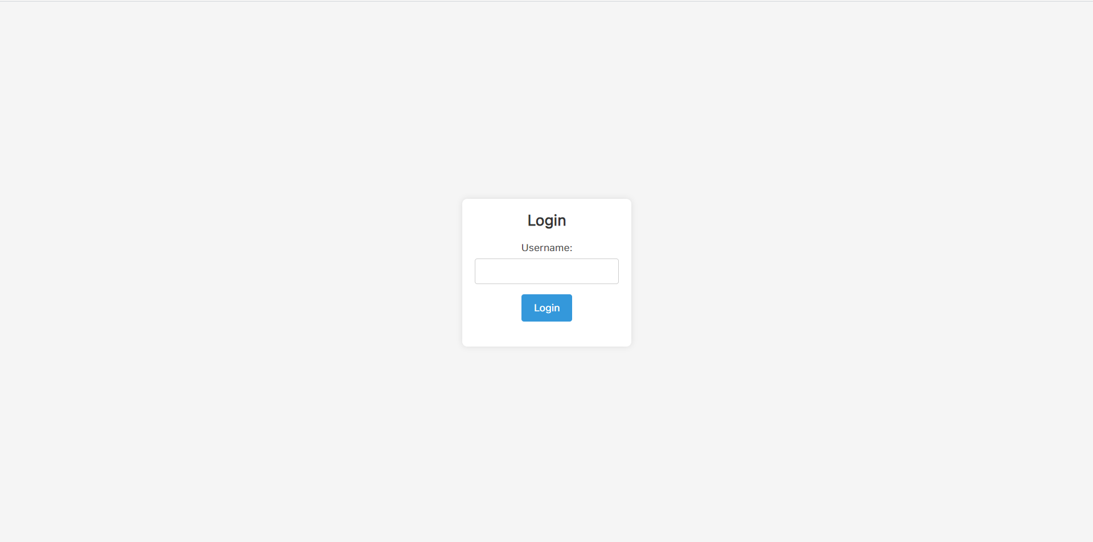

User can enter their username into the input box and press login / enter to login to lobby page

* 3.2 Lobby Overview

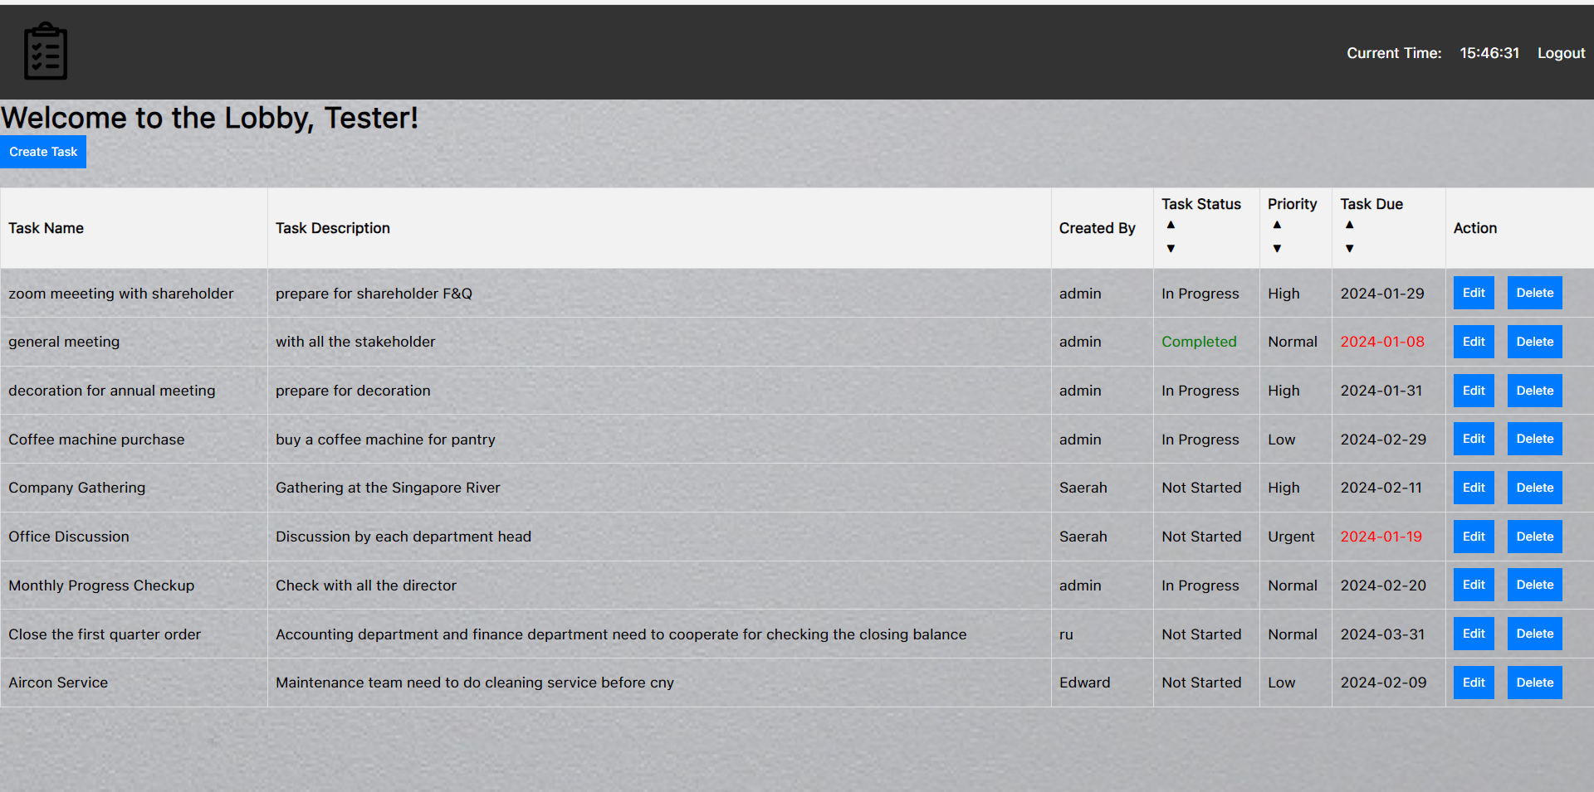

This is the lobby view that login by ‘Tester’

* 3.3 Logout

Simply click the logout button that the top right corner and user will bring back to the login page

# Creating and Managing Tasks

* 4.1 Creating a New Task

Pre-request: User need to prompt in their username to go into the lobby page

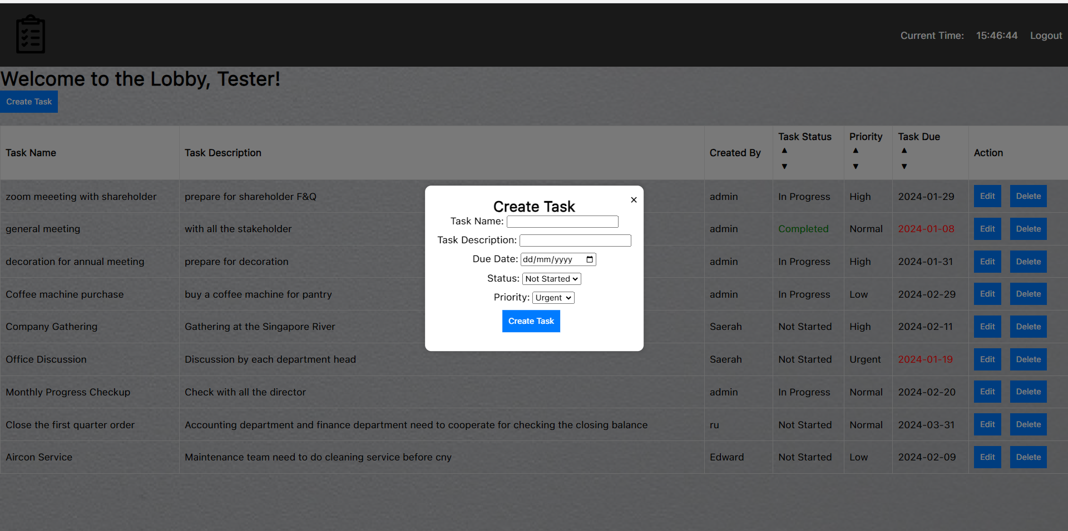

By press the create task button there will be an overlay form to let the user to fill.

User are required to fill **task name, task description, due date of the task, task status, and priority.**

Result of Creating **task name: tester task, task description: tester,**

**due date of the task** **:2024-01-27, task status: not started, and priority: normal.**

* 4.2 Editing a Task

Pre-request: User need to prompt in their username to go into the lobby page.

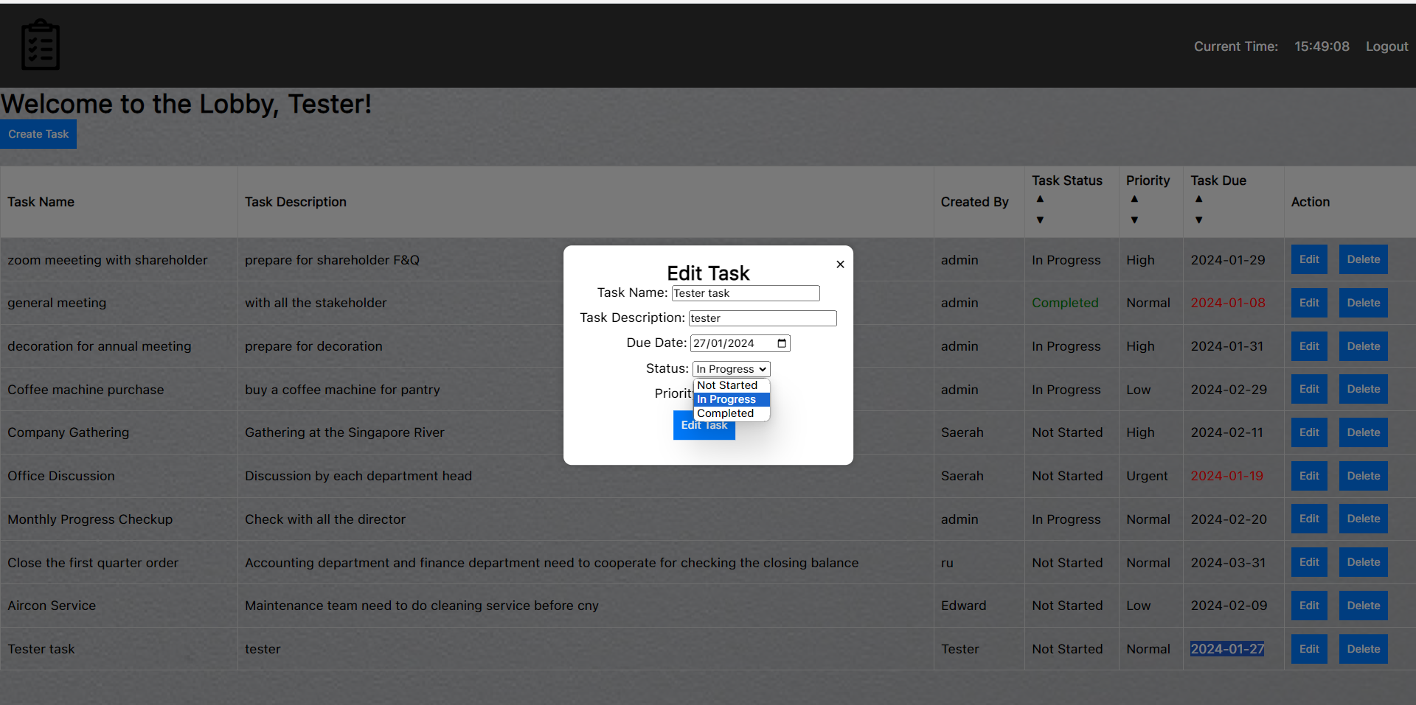

By changing the tester task (which created earlier) to the in progress and priority to High

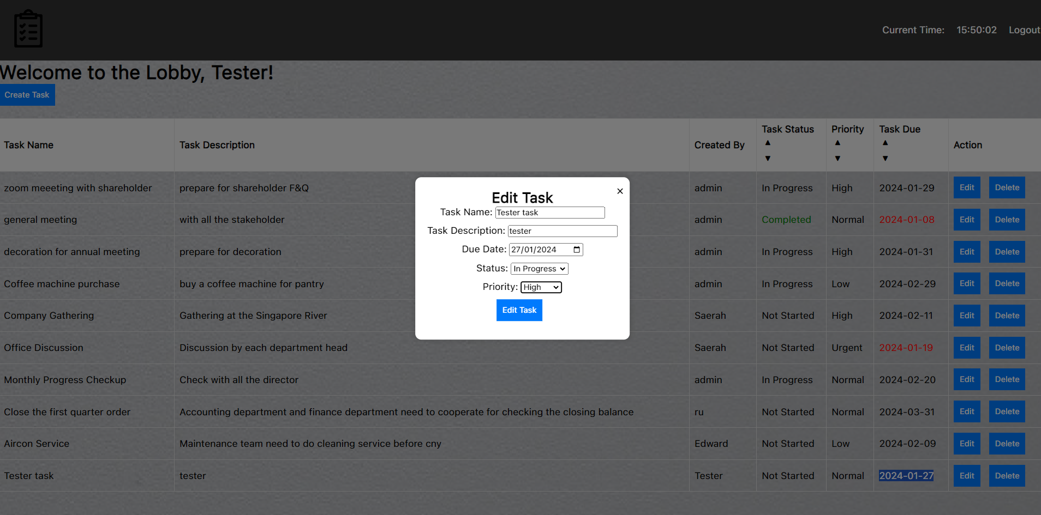

Result:

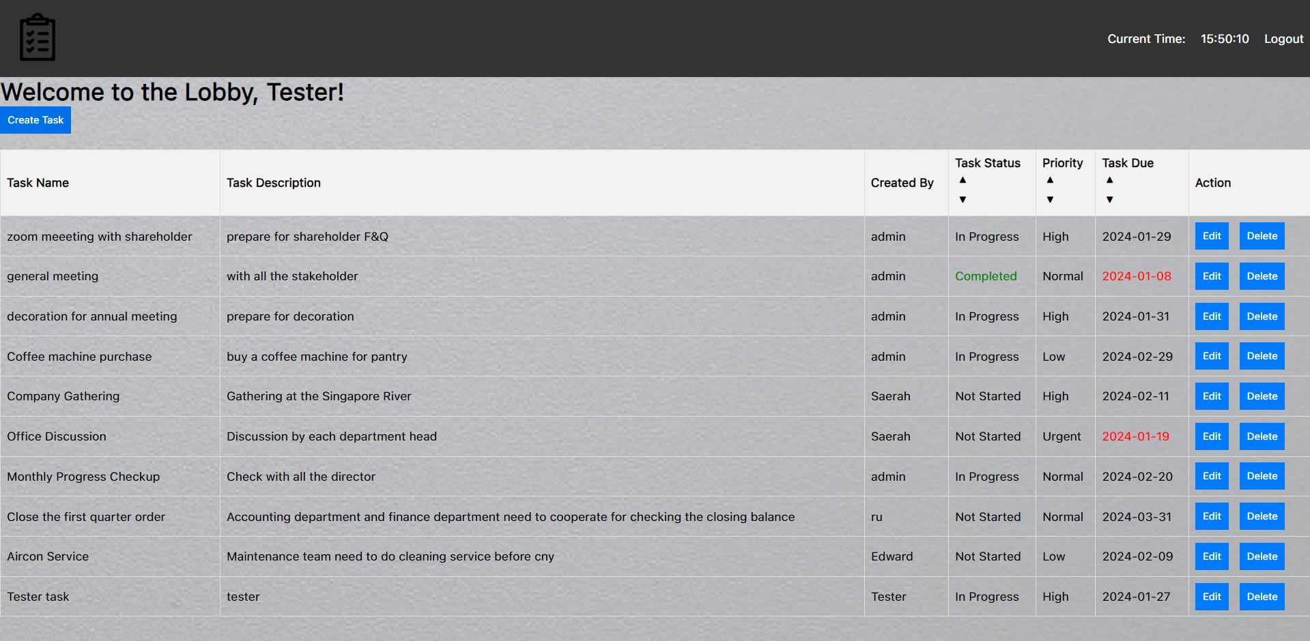

* 4.3 Deleting a Task

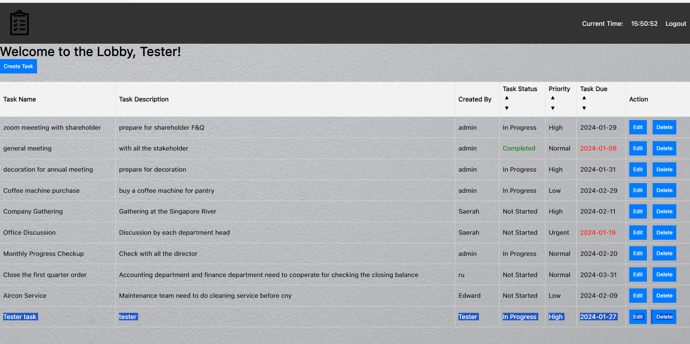Deleting the Tester Task(which created earlier)

After Delete:

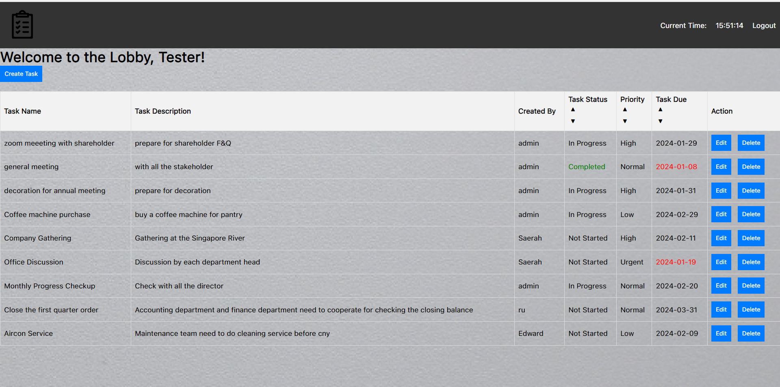

* 4.4 Sorting Tasks with Task Status , Prioritization , Task Due

4.4.1 Sort Task by Status

Sort Task Status into completed, in progress, not started (Press the ▲button)

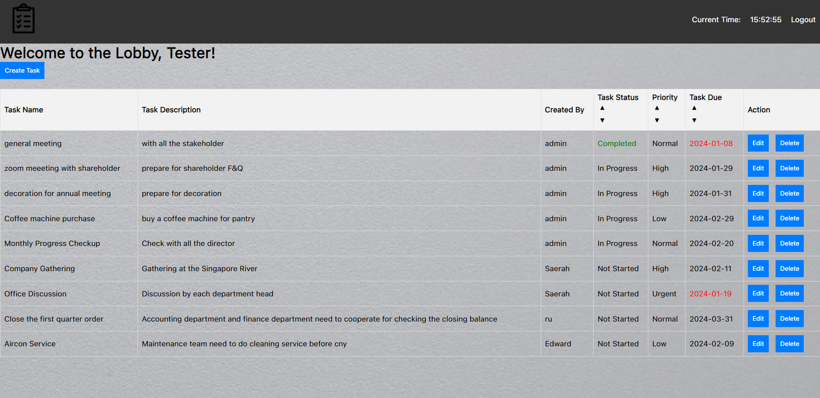

Sort Task Status into not started, in progress, completed (Press the ▼ button)

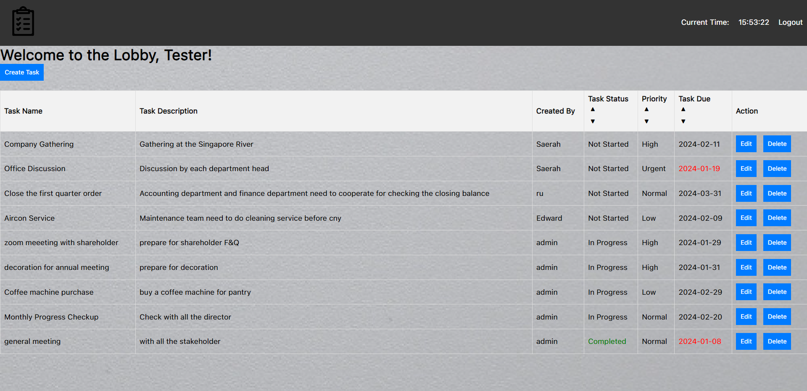

4.4.2 Sort Task by Priority

Task sort by highest priority- (Press the ▲ button)

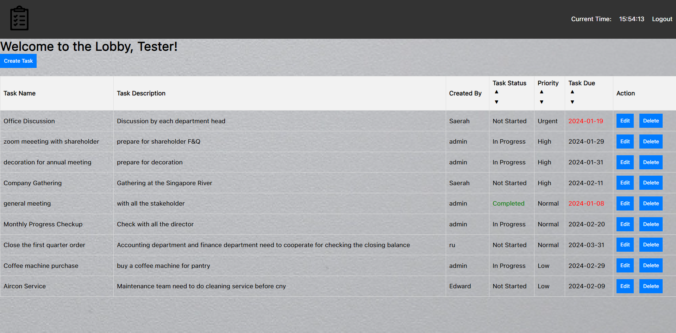

‘Urgent’ task will be first then come with ‘High’ and normal, low.

Task sort by lowest priority- (Press the ▼button)

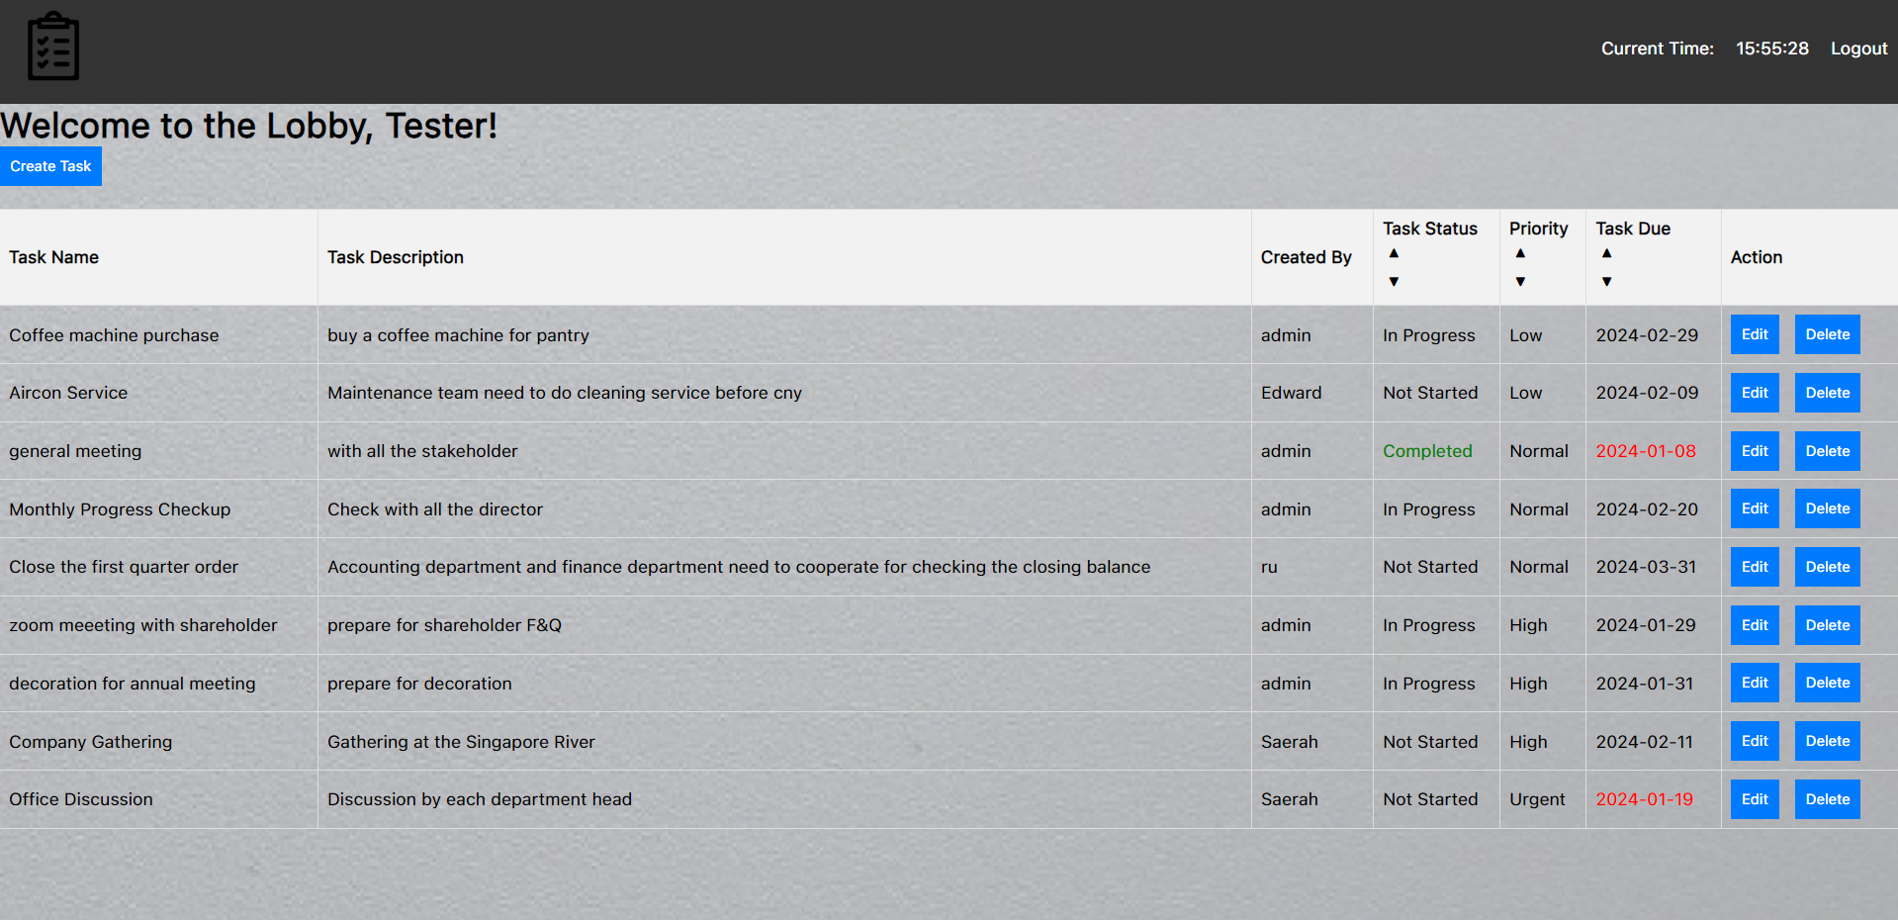

Task will be sorted into the Low, Normal, High, and Urgent

4.4.3 Sort Task by Due Date

Task sort by the earliest date (Press the ▲button)

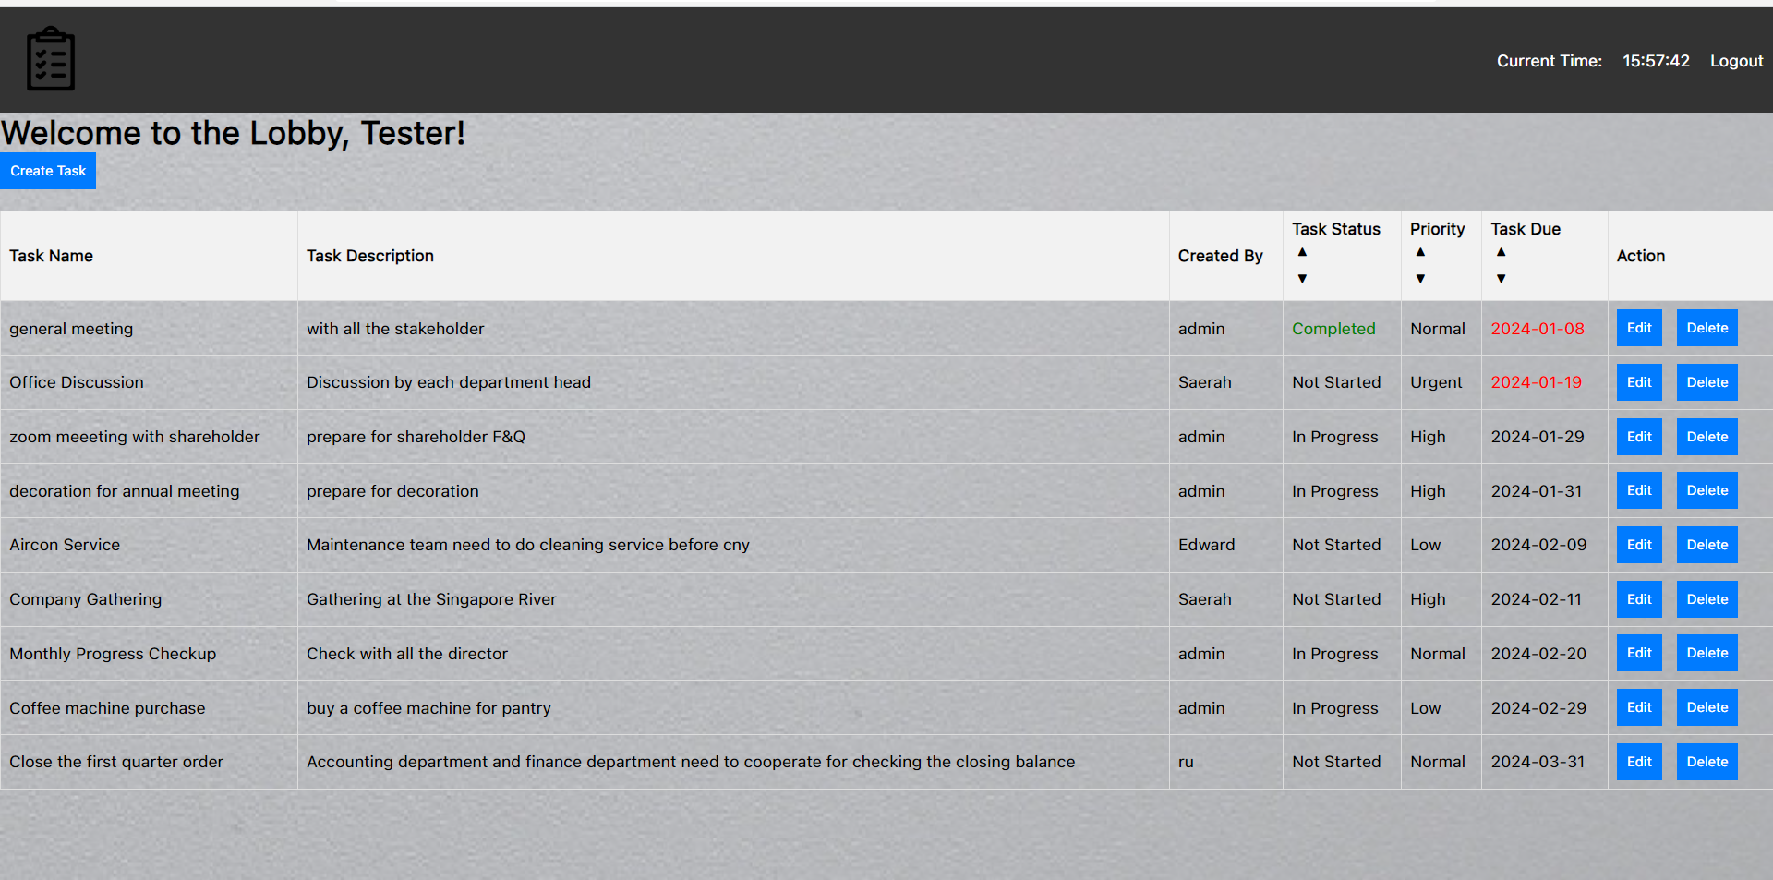

Task will sort into the earliest date by the ’task due’, so normally it come with due date task first

Task sort by the latest date (Press the ▼ button)

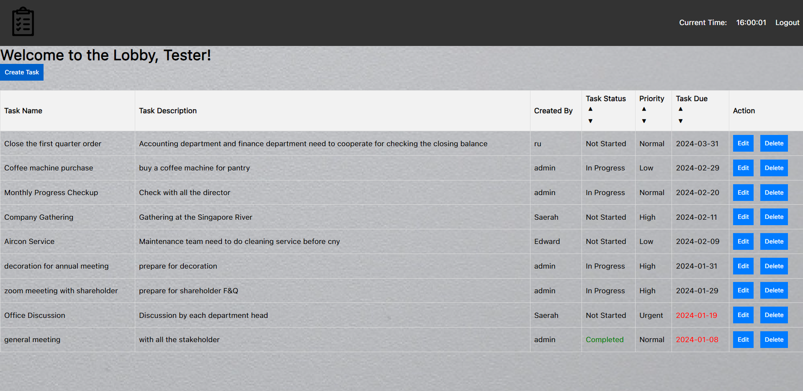

Task will be sort with the task that will due in most latest first

# Frequently Asked Questions (FAQ)

1. **What is the complexity of the application?**

View All Tasks: Complexity: O(n)

Explanation: The time complexity for viewing all tasks is linear, where "n" is the number of tasks.

Create Task: Complexity: O(1)

Explanation: Creating a task involves inserting it into database once at the time only.

Edit Task: Complexity: O(1)

Explanation: Editing a task typically involves updating an existing record in your data structure. Like creating a task, the complexity is constant.

Delete Task: Complexity: O(1)

Explanation: Deleting a task is allow once in a time, which is done in constant time.

1. **What is the limit size for a task?**

Task name: 90 characters

Task description: 255 characters